Exercise 3: Stored Procedures

Scenario 1: The bank needs to process monthly interest for all savings accounts.
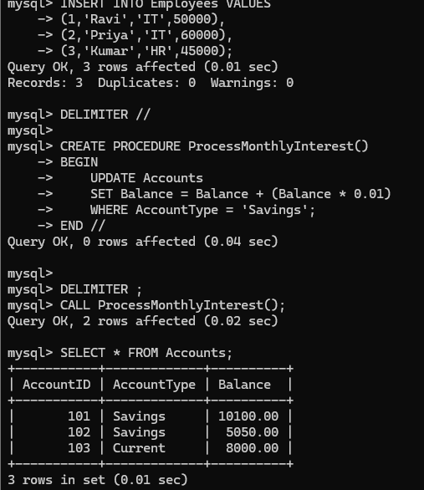

Scenario 2: The bank wants to implement a bonus scheme for employees based on their performance

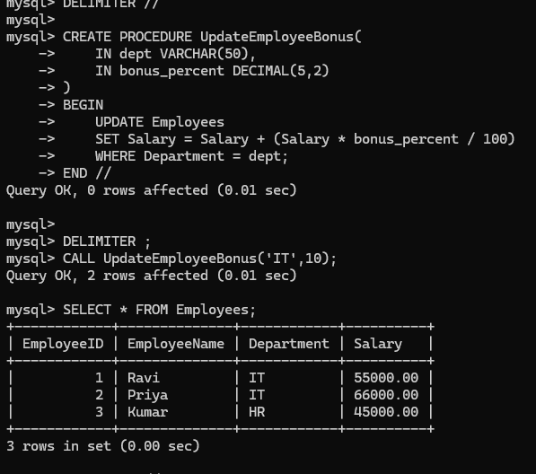

Scenario 3: Customers should be able to transfer funds between their accounts.

